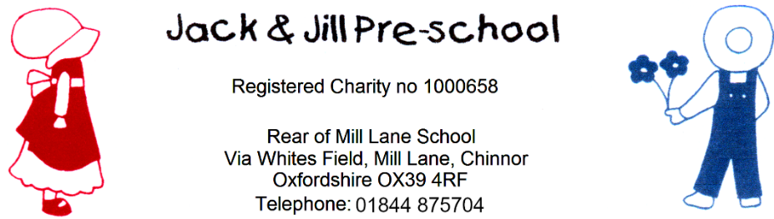

Policy on children’s records
Reviewed September 2025
Next review due September 2026

Policy statement
We have record keeping systems in place that meet legal requirements; the means we use to store and share that information takes place within the framework of the General Data Protection Regulations (2018) and the Human Rights Act (1998).
This policy and procedure should be read alongside our Privacy Notice, Confidentiality and Client Access to Records Policy and our Information Sharing Policy.
Procedures
If a child attends another setting, we gain consent from the parents to liaise with the other setting in order to share developmental progress records. Where appropriate, we will incorporate comments from other providers, as well as parents and/or carers into the child’s records.

Most of our records are kept on the EYLog system. This system keeps an ongoing ‘live’ record of the children’s development. It is accessed by tablet/computers held in preschool or staff home computer.

Developmental records
- Observations of children in the setting, or at home. These can be contributed to by our staff and the child’s parents. Photographs, video clips and summary developmental reports.
- Photographs of the child showing activities and development which can be accessed, and contributed to, by our staff, and the child’s parents.
- Video clips of the child showing activities and development which can be accessed, and contributed to, by our staff, and the child’s parents.
- Photographs demonstrating samples of the child’s work. Originals are used for displays or sent home to parents.
Personal records
These may include the following (as applicable):
- Personal details: including the child’s ‘All about me’ form, and any consent forms.
- The child’s days and times of attendance, a record of the child’s fees, any fee reminders or records of disputes about fees.
- Child’s development, health and well-being: including a summary of the child’s EYFS profile report, a record of discussions about every-day matters about the child’s development, health and well-being with the parent.
- Early Support: including any additional focussed intervention provided by our setting (e.g. support for behaviour, language or development that needs an SEN action plan) and records of any meetings held.
- Welfare and child protection concerns: including records of all welfare and protection concerns, and our resulting action, meetings and telephone conversations about the child, an Education, Health and Care Plan and any information regarding a Looked After Child.
- Correspondence and Reports: including a copy of the child’s 2-Year-Old Progress Check (if available), all letters and emails to and from other agencies and any confidential reports from other agencies.

- These confidential records that are not on the secure EYLog system are stored in lockable cabinets, which are locked when not in use.
- We read any correspondence in relation to a child, note any actions and file it immediately.
- We ensure that access to children’s files is restricted to those authorised to see them and make entries in them: this being our supervisor, deputy or designated person for child protection, the child’s key person, or other staff as authorised by our supervisor.
- We may be required to hand children’s personal files to Ofsted as part of an inspection or investigation process; or to local authority staff conducting a S11 audit, as long as authorisation is seen. We ensure that children’s personal files are not handed over to anyone else to look at.
- Parents have access, in accordance with our Privacy Notice, Confidentiality and Client Access to Records Policy, to the files and records of their own children, but do not have access to information about any other child.
- Our staff will not discuss personal information given by parents with other members of staff, except where it affects planning for the child's needs. Our staff induction programme includes an awareness of the importance of confidentiality in the role of the key person.
- We retain children’s records for three years after they have left the setting; except records that relate to an accident or child protection matter, which are kept until a child reaches the age of 21 years or 24 years respectively. These are kept in a secure place.

Archiving children’s files
- When a child leaves our setting, we remove all paper documents from the child’s personal file and together with printed records from EYLog are placed in an archive file, with the group of children’s names and their year group.
- We seal this and place it in an archive box, stored in a safe place for three years. After three years it is destroyed.
- Where there were s.47 child protection investigations, we mark the envelope with a star and archive it for 25 years in the secure locked cabinet.
- We store financial information according to our finance procedures.

Other records
- We keep a daily record of the names of the children we are caring for, their hours of attendance and the names of their key person.
- Trainees and Students observing and working in the setting are advised of our Confidentiality and Client Access to Records Policy and are required to respect it.

Legal framework
- General Data Protection Regulations (2018)
- Human Rights Act (1998)

