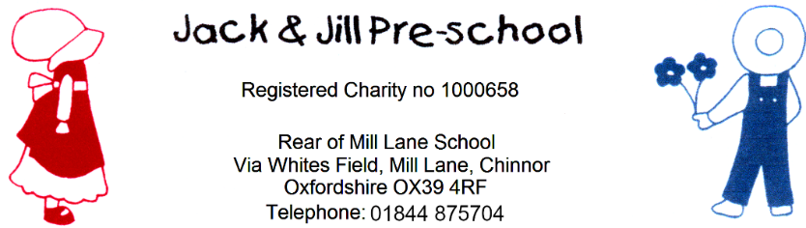
Privacy Notice
Reviewed September 2026
Next review due September 2027
Data Controller
Jack and Jill Pre School is the data controller for the personal information covered by this Privacy Notice. If you have any questions about how we use your personal data or wish to exercise your data protection rights, please contact the Preschool Manager using the preschool's usual contact details.
Introduction
We are committed to ensuring that any personal data we hold about you and your child is protected in accordance with data protection laws and is used in line with your expectations.
This privacy notice explains what personal data we collect, why we collect it, how we use it and how we protect it. We are registered with the Information Commissioner’s Office (ICO) and process personal data in accordance with the UK General Data Protection Regulation (UK GDPR) and the Data Protection Act 2018.

What personal data do we collect?
We collect personal data about you and your child to provide care and learning that is tailored to meet your child’s individual needs. We also collect information in order to verify your eligibility for free childcare as applicable.
Personal details that we collect about your child include: your child’s name, date of birth, address, health and medical needs, development needs, and any special educational needs. Where applicable we will obtain child protection plans from social care and health care plans from health professionals. We will also ask for information about who has parental responsibility for your child and any court orders pertaining to your child.
Personal details that we collect about you include: your name, home and work address, phone numbers, emergency contact details, and family details.
This information will usually be collected directly from you through the EYLog child profile form and All About Me. Where we rely on consent for a specific use of personal data, we will obtain that consent separately.
If you apply for free childcare, we will also collect:
- One parent’s date of birth and national insurance number (or unique taxpayer reference (UTR) if you’re self-employed).
- We may also collect information regarding benefits and family credits that you receive.

Why we collect this information and the legal bases for handling your data
We collect and use personal data about you and your child where this is necessary to provide our childcare services and fulfil our contractual arrangements with you, and where necessary to comply with our legal obligations. This includes using your data to:
- contact you in case of an emergency
- to support your child’s wellbeing and development
- to manage any special educational, health or medical needs of your child whilst at our setting
- to carry out regular assessment of your child’s progress and to identify any areas of concern
- to maintain contact with you about your child’s progress and respond to any questions you may have
- to process your claim for free childcare (only where applicable)
- to keep you updated with information about our service
With your consent (collected via EYLog), we will also record your child’s activities for their individual learning records. This may include photographs and videos. You can withdraw your consent for photographs and videos at any time by informing the preschool.
We have a legal obligation to:
- collect and retain data relating to attendance, the administration of medication and records of accidents occurring while your child is in our care
- Collect and provide required information to the Local Authority for the statutory Early Years Census, where applicable. This may include your child’s ethnicity. Ethnicity is provided by the parent or guardian and parents may choose not to provide this information.
- process safeguarding related data about your child should we have concerns about their welfare.
- We may transfer relevant records and information about your child to the school or setting they will be attending, in accordance with our Transfer of Records Policy and applicable data protection and safeguarding requirements.
Who we share your data with
In order for us to deliver childcare services we will also share your data as required with the following categories of recipients:
- Ofsted – during an inspection or following a complaint about our service
- the Local Authority (where you claim free childcare as applicable)
- the government’s eligibility checker (as above)
- our setting's online learning journal provider EyLog
- the school that your child will be attending
We will also share your data:
- if we are legally required to do so, for example, by law, by a court or the Charity Commission;
- if it is necessary to protect your child and other children; for example by sharing information with social care or the police;
- if it is necessary to protect our or others’ rights, property or safety.
We will only share personal data with other organisations where there is a lawful basis to do so and where the sharing is necessary and appropriate.
How do we protect your data?
We protect unauthorised access to your personal data and prevent it from being lost, accidentally destroyed, misused, or disclosed by storing it securely (see our Children’s Records and Provider Records policies):
In the case of hard copy records, files are kept in a locked cupboard at pre-school.
In the case of electronic records, files are kept in secure online cloud storage. In terms of children’s online learning journeys Eylog Electronic records, including children’s online learning journeys on EYLog, are stored securely and access is restricted to authorised users through secure login and password controls. Access to children’s information is limited to those who have a legitimate need to access it. We take appropriate technical and organisational measures to protect personal data from unauthorised access, loss, misuse or disclosure

How long do we retain your data?
We retain personal data only for as long as it is necessary for the purpose for which it was collected and in accordance with our record retention procedures. Children’s general records are normally retained for three years after they leave the setting. Some records, including accident, medication, safeguarding and child protection records, may need to be retained for longer where required by law, statutory guidance or other applicable requirements. Please see our Children’s Records and Provider Records Policies for further information.
Automated decision-making
We do not make any decisions about your child based solely on automated decision-making.

Your rights with respect to your data
You have the right to:
request access to personal data we hold about you or your child
• request correction of inaccurate or incomplete personal data
• request deletion of personal data in certain circumstances
• request restriction of the processing of personal data in certain circumstances
• object to the processing of personal data in certain circumstances
• request the transfer of personal data to another organisation where the right to data portability applies
• withdraw consent at any time where we rely on consent to process personal data
If you wish to exercise any of these rights at any time or if you have any questions, comments or concerns about this privacy notice, or how we handle your data please contact us. If you continue to have concerns about the way your data is handled and remain dissatisfied after raising your concern with us, you have the right to complain to the Information Commissioner Office (ICO). The ICO can be contacted at: Information Commissioner’s Office, Wycliffe House, Water Lane, Wilmslow, Cheshire, SK9 5AF. Helpline number: 0303 123 1113 ico.org.uk/

Changes to this notice
We keep this notice under regular review. You will be notified of any changes where appropriate.

Further information: please refer to our policies which can be emailed on request.

