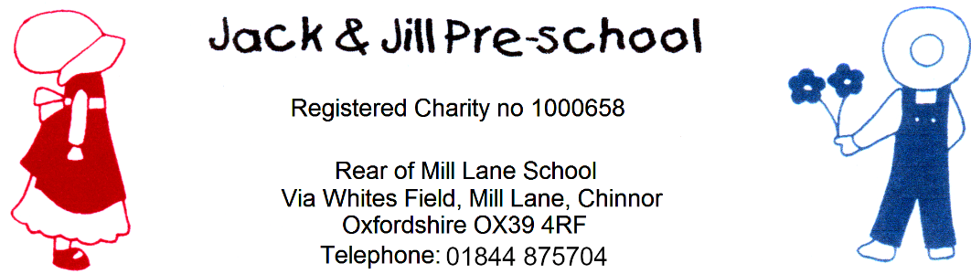

Reviewed Sept 2025
Next review: Sept 2026

Policy on Confidentiality and client access to records
In our setting, staff and managers can be said to have a ‘confidential relationship’ with families. It is our intention to respect the privacy of children and their parents and carers, while ensuring that they access high quality early years’ care and education in our setting. We aim to ensure that all parents and carers can share their information in the confidence that it will only be used to enhance the welfare of their children. We have record keeping systems in place that meet legal requirements; the means that we use to store and share that information takes place within the framework of the General Data Protection Regulations (2018) and the Human Rights Act (1998).

Confidentiality procedures
Most things that happen between the family, the child and the setting are confidential to our setting. In exceptional circumstances information is shared, for example with other professionals or possibly social care or the police.
Information shared with other agencies is done in line with our Information Sharing Policy.
We check where appropriate whether parents regard the information they share with us to be confidential or not.
Some parents may share information about themselves with other parents as well as with our staff; we cannot be held responsible if information is shared by those parents whom the person has ‘confided’ in.
Information shared between parents in a discussion or training group or committee meeting is usually bound by a shared agreement that the information is confidential to the group and not discussed outside of it. We are not responsible should that confidentiality be breached by participants.
We inform parents when we need to record confidential information beyond the general personal information we keep (see our Children's Records Policy and Privacy Notice) - for example with regard to any injuries, concerns or changes in relation to the child or the family, any discussions with parents on sensitive matters, any records we are obliged to keep regarding action taken in respect of child protection and any contact and correspondence with external agencies in relation to their child.
We keep all records securely (see our Children's Records Policy and Privacy Notice).
In line with EYFS 2025, we collect and maintain more than two emergency contact details for each child wherever possible, and these are stored confidentially as part of our Children’s Records Policy.
Information is kept in a manual file and electronically. We use the secure EY LOG record keeping system. Staff use a computer to type reports, or letters. Where this is the case, the typed document is deleted from the PC and only the hard copy kept. We do not keep electronic records on children, other than the register and financial data.
Our staff discuss children’s general progress and well-being together in meetings, but more sensitive information is restricted to our manager and the child’s key person, and is shared with other staff on a need to know basis.
Attendance and absence records are kept and may be shared with safeguarding agencies where there are concerns about unexplained or prolonged absences, in line with EYFS 2025.
We do not discuss children with staff who are not involved in the child’s care, or with other parents or anyone else outside of the setting.
Our discussions with other professionals take place within a professional framework and not on an informal or ad-hoc basis.
Where third parties share information about an individual to us, we check if it is confidential, both in terms of the party sharing the information and of the person whom the information concerns.

Client access to records procedures
Parents may request access to any confidential records we hold on their child and family following the procedure below:
The parent is the ‘subject’ of the file in the case where a child is too young to give ‘informed consent’ and has a right to see information that our setting has compiled on them.
Any request to see the child’s personal file by a parent or person with parental responsibility must be made in writing to the setting leader.
We acknowledge the request in writing, informing the parent that an arrangement will be made for him/her to see the file contents, subject to third party consent.
Our written acknowledgement allows one month for the file to be made ready and available. We will be able to extend this by a further two months where requests are complex or numerous. If this is the case, we will inform you within one month of the receipt of the request and explain why the extension is necessary
A reasonable fee to cover admin costs may be charged to the parent.
Our manager may seek legal advice before sharing a file.
Our manager and deputy go through the file and ensure that all documents have been filed correctly, that entries are in date order and that there are no missing pages. They note any information, entry or correspondence or other document which mentions a third party.
We write to each of those individuals explaining that the subject has requested sight of the file, which contains a reference to them, stating what this is.
They are asked to reply in writing to us giving or refusing consent for disclosure of that material.
We keep copies of these letters and their replies on the child’s file.
‘Third parties’ include each family member noted on the file; so where there are separate entries pertaining to each parent, step parent, grandparent etc., we write to each of them to request third party consent.
Third parties also include workers from any other agency, including children's social care and the health authority for example. Agencies will normally refuse consent to share information, preferring instead for the parent to be redirected to those agencies for a request to see their file held by that agency.
Members of our staff should also be written to, but we reserve the right under the legislation to override a refusal for consent or to just delete the name of the staff member and not the information. We may grant refusal if the member of staff has provided information that could be considered ‘sensitive’ and the staff member may be in danger if that information is disclosed; or if that information is the basis of a police investigation. However, if the information is not sensitive, then it is not in our interest to withhold that information from a parent. In each case this should be discussed with members of staff and decisions recorded.
When we have received all the consents/refusals we take a photocopy of the complete file. On the copy of the file, we remove any information that a third party has refused consent for us to disclose and blank out any references to the third party, and any information they have added to the file, using a thick marker pen.
The copy file is then checked by the line manager and legal advisors to verify that the file has been prepared appropriately.
What remains is the information recorded by the setting, detailing the work initiated and followed by them in relation to confidential matters. This is called the ‘clean copy’.
We photocopy the ‘clean copy’ again and collate it for the parent to see.
Our manager informs the parent that the file is now ready and invites him/ her to make an appointment to view it.
Our manager and deputy will meet with the parent to go through the file, explaining the process as well as what the content of the file records about the child and the work that has been done. Only the person(s) with parental responsibility can attend that meeting, or the parent’s legal representative or interpreter.
The parent may take a copy of the prepared file away; but, to ensure it is properly explained to and understood by the parent, we never hand it over without discussion.
It is an offence to remove material that is controversial or to rewrite records to make them more acceptable. Our recording procedures and guidelines ensure that the material reflects an accurate and non-judgemental account of the work we have done with the family.
If a parent feels aggrieved about any entry in the file, or the resulting outcome, then we refer the parent to our complaints procedure.
The law requires that the information we hold must be held for a legitimate reason and must be accurate, (see our Privacy Notice). If a parent says that the information we hold is inaccurate, then the parent has a right to request for it to be changed. However, this only pertains to factual inaccuracies. Where the disputed entry is a matter of opinion, professional judgement, or represents a different view of the matter than that held by the parent, we retain the right not to change that entry, but we can record the parent’s view of the matter. In most cases, we would have given a parent the opportunity at the time to state their side of the matter, and it would have been recorded there and then.
If there are any controversial aspects of the content of a child’s file, we must seek legal advice. This might be where there is a court case between parents, where social care or the police may be considering legal action, or where a case has already completed and an appeal process is underway.
We never ‘under-record’ for fear of the parent seeing, nor do we make ‘personal notes’ elsewhere.
Records of safeguarding training are maintained in line with the EYFS 2025 Annex and may be accessed by Ofsted or the Local Authority to evidence compliance.

Telephone advice regarding general queries may be made to The Information Commissioner’s Office Helpline 0303 123 1113.
All the undertakings above are subject to the paramount commitment of our setting, which is to the safety and well-being of the child. Please see also our policy on Safeguarding Children and Child Protection.

Legal framework
General Data Protection Regulations (2018)
Human Rights Act (1998)

