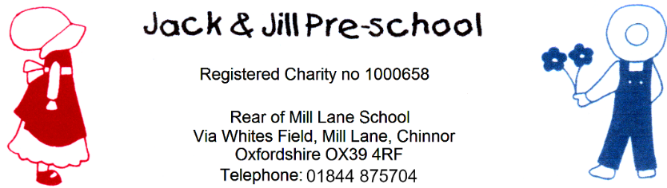
Privacy Notice
Reviewed September 2024
Next review due September 2025
Introduction
We are committed to ensuring that any personal data we hold about you and your child is protected in accordance with data protection laws and is used in line with your expectations.
This privacy notice explains what personal data we collect, why we collect it, how we use it and how we protect it. We are registered with the Information Commissioner's Office (ICO) and are compliant with the General Data Protection Regulations (GDPR) (2018) and Data Protection Act

What personal data do we collect?
We collect personal data about you and your child to provide care and learning that is tailored to meet your child’s individual needs. We also collect information in order to verify your eligibility for free childcare as applicable.
Personal details that we collect about your child include: your child’s name, date of birth, address, health and medical needs, development needs, and any special educational needs. Where applicable we will obtain child protection plans from social care and health care plans from health professionals. We will also ask for information about who has parental responsibility for your child and any court orders pertaining to your child.
Personal details that we collect about you include: your name, home and work address, phone numbers, emergency contact details, and family details.
This information (and your consent to us holding it, where this applies) will be collected from you directly in the EYLog child profile form and all about me.
If you apply for free childcare, we will also collect:
- One parent’s date of birth and national insurance number (or unique taxpayer reference (UTR) if you’re self-employed).
- We may also collect information regarding benefits and family credits that you receive.

Why we collect this information and the legal bases for handling your data
We collect and use personal data about you and your child in order to provide childcare services and fulfil the contractual arrangement you have entered into. This includes using your data to:
- contact you in case of an emergency
- to support your child’s wellbeing and development
- to manage any special educational, health or medical needs of your child whilst at our setting
- to carry out regular assessment of your child’s progress and to identify any areas of concern
- to maintain contact with you about your child’s progress and respond to any questions you may have
- to process your claim for free childcare (only where applicable)
- to keep you updated with information about our service
With your consent (collected via EYLog), we will also record your child’s activities for their individual learning records. This may include photographs and videos. You have the opportunity to withdraw your consent for images taken by confirming so in writing at any time.
We have a legal obligation to:
- collect and retain data relating to attendance, the administration of medication and records of accidents occurring while your child is in our care
- collect data on your child's ethnicity and transfer this information to the Local Authority who must supply the anonymised data to the DfE for statistical purposes
- process safeguarding related data about your child should we have concerns about their welfare.
- transfer records and certain information about your child to the school that your child will be attending (see Transfer of Records policy).

Who we share your data with
In order for us to deliver childcare services we will also share your data as required with the following categories of recipients:
- Ofsted – during an inspection or following a complaint about our service
- the Local Authority (where you claim free childcare as applicable)
- the government’s eligibility checker (as above)
- our setting's online learning journal provider EyLog
- the school that your child will be attending
We will also share your data:
- if we are legally required to do so, for example, by law, by a court or the Charity Commission;
- if it is necessary to protect your child and other children; for example by sharing information with social care or the police;
- if it is necessary to protect our or others’ rights, property or safety.
We will never share your data with any other organisation to use for their own purposes.

How do we protect your data?
We protect unauthorised access to your personal data and prevent it from being lost, accidentally destroyed, misused, or disclosed by storing it securely (see our Children’s Records and Provider Records policies):
In the case of hard copy records, files are kept in a locked cupboard at pre-school.
In the case of electronic records, files are kept in secure online cloud storage. In terms of children’s online learning journeys (eyLog), no data is stored on the tablets. As soon as an observation has been recorded and uploaded to the eyLog server, it is automatically deleted from the tablet. All data is held in encrypted form and is accessed subject to a secure login and password. The only people who can access a child’s learning journey are the relevant pre-school staff and the child’s parent.

How long do we retain your data?
We retain your child’s personal data for up to 7 years after your child no longer attends our setting, or until our next Ofsted inspection after your child leaves our setting. Medication records and accident records are kept for longer according to legal requirements. In some instances (child protection, or other support service referrals) we are obliged to keep your data for longer if it is necessary to comply with legal requirements (see our Children’s Records and Provider Records policies).

Automated decision-making
We do not make any decisions about your child based solely on automated decision-making.

Your rights with respect to your data
You have the right to:
- request access, amend or correct your/your child’s personal data
- request that we delete or stop processing your/your child’s personal data, for example where the data is no longer necessary for the purposes of processing;
- request that we transfer your, and your child’s personal data to another person

If you wish to exercise any of these rights at any time or if you have any questions, comments or concerns about this privacy notice, or how we handle your data please contact us. If you continue to have concerns about the way your data is handled and remain dissatisfied after raising your concern with us, you have the right to complain to the Information Commissioner Office (ICO). The ICO can be contacted at: Information Commissioner’s Office, Wycliffe House, Water Lane, Wilmslow, Cheshire, SK9 5AF. Helpline number: 0303 123 1113 ico.org.uk/

Changes to this notice
We keep this notice under regular review. You will be notified of any changes where appropriate.

Further information: please refer to our policies which can be emailed on request.

