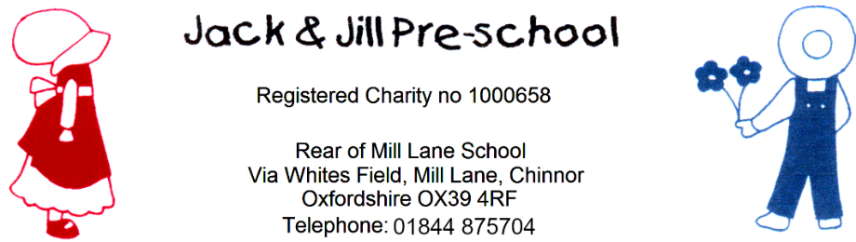

Reviewed September 2026
Next review: September 2027

Policy on Information Sharing
Policy statement
Jack and Jill Pre-school recognise that parents have a right to know that the information they share with us will be regarded as confidential, as well as to be informed about the circumstances when, and the reasons why, we are obliged to share information.
We record and share information about children and their families (data subjects) in line with the six data protection principles of the UK General Data Protection Regulation (UK GDPR) and the Data Protection Act 2018. These are further explained in our Privacy Notice, which is given to parents at the point of registration. The six principles state that personal data must be:
Processed fairly, lawfully and in a transparent manner in relation to the data subject.
Collected for specified, explicit and legitimate purposes and not further processed for other purposes incompatible with those purposes.
Adequate, relevant and limited to what is necessary in relation to the purposes for which data is processed.
Accurate and where necessary, kept up to date.
Kept in a form that permits identification of data subjects for no longer than is necessary for the purposes for which the data is processed.
Processed in a way that ensures appropriate security of the persona data including protection against accidental loss, destruction or damage, using appropriate technical or organisational measures
We may share confidential information without consent where there is a lawful basis to do so, including where this is necessary to safeguard a child or another person. Data protection law does not prevent the sharing of information for safeguarding purposes where it is necessary, proportionate and lawful. We will not allow concerns about obtaining consent to prevent us from sharing information where a child may be at risk of harm. Where appropriate, we will inform the parent or carer that information is being shared, unless doing so could place the child or another person at greater risk, prejudice an investigation, or where we have been advised not to inform them.

Procedures
Our procedure is based on the UK GDPR principles listed above and current government guidance on information sharing for safeguarding practitioners. We also follow the guidance and procedures of the Oxfordshire Safeguarding Children Partnership (OSCP).
We are aware that the UK General Data Protection Regulation (UK GDPR), the Data Protection Act 2018 and human rights law are not barriers to justified information sharing, but provide a framework to ensure that personal information is shared appropriately.
Our policy and procedures on Information Sharing provide guidance to appropriate sharing of information both within the setting, as well as with external agencies.
We aim to be open and honest with the individual and/or their family, where appropriate, from the outset about why, what, how and with whom information will or could be shared. We will seek consent where appropriate. However, information may be shared without consent where there is a lawful basis to do so, including where this is necessary to safeguard a child or another person. We will not seek consent where doing so could place a child or another person at increased risk of harm or prejudice an investigation. A Privacy Notice is given to parents at the point of registration to explain this further.

In our setting we ensure parents:
Receive a copy of our Privacy Notice and have access to our Information Sharing Policy when starting their child in the setting.
have information about our Safeguarding Children and Child Protection Policy; and
have information about the other circumstances when information will be shared with external agencies, for example, with regard to any special needs the child may have or transition to school.

We will seek advice from other practitioners if we are in any doubt about sharing the information concerned, without disclosing the identity of the individual where possible.

Our staff discuss concerns about a child routinely in supervision and at staff meetings if appropriate, and any actions are recorded in the child’s file.
Our Safeguarding Children and Child Protection Policy sets out the duty of all staff to report safeguarding concerns immediately to the Designated Safeguarding Lead (DSL) or Deputy DSL, who will follow the appropriate safeguarding procedures and contact Children’s Social Care where required.
We seek advice if we need to share information without consent to disclose.
We endeavour to share with informed consent where appropriate and, where possible, respect the wishes of those who do not consent to share confidential information. We may still share information without consent if, in our judgement, there is good reason to do so, such as where safety may be at risk. We will need to base our judgement on the facts of the case. When we are sharing or requesting personal information from someone, we must be certain of the basis upon which we are doing so. Where we have consent, we are mindful that an individual might not expect information to be shared.
Our guidelines for consent are part of this procedure.
Our manager is conversant with this and she is able to advise staff accordingly.
We keep records of safeguarding training in accordance with the EYFS statutory framework 2026 and may share relevant training information with Ofsted or the Local Authority where required.
We consider safety and well-being: We base our information sharing decisions on considerations of the safety and well-being of the individual and others who may be affected by their actions.
In our setting we:
record concerns and report these to the Designated Safeguarding Lead (DSL) or Deputy DSL, for safeguarding and child protection matters, using the ‘Welfare Concerns Form’.
record decisions made and the reasons why information will be shared and to whom; and
follow the procedures for reporting concerns and record keeping as set out in our Safeguarding Children and Child Protection Policy.

Our guidelines are that the sharing is necessary, proportionate, relevant, adequate, accurate, timely and secure: We ensure that the information we share is necessary for the purpose for which we are sharing it, is shared only with those individuals who need to have it, is accurate and up-to-date, is shared in a timely fashion, and is shared securely.
Our Safeguarding Children and Child Protection Policy and Children's Records Policy sets out how and where information is recorded and what information should be shared with another agency when making a referral.
In line with EYFS 2026, we may share attendance and absence information with relevant agencies where there are concerns about unexplained or prolonged absence. We also maintain more than two emergency contacts per child wherever possible, and this information may be shared when safeguarding requires it.

We will keep a record of our decision and the reasons for it – whether it is to share information or not. If we decide to share, then we record what we have shared, with whom and for what purpose.
Where information is shared, we record the reasons for doing so in the child's file; where it is decided that information is not to be shared that is recorded too.

Consent
When parents choose our setting for their child, they will share information about themselves and their families. This information is regarded as confidential. Parents have a right to be informed that we will seek their consent to share information in most cases, as well as the kinds of circumstances when we may not seek their consent, or may override their refusal to give consent. We inform them as follows:
Our policies and procedures set out our responsibility regarding gaining consent to share information and when it may not be sought or overridden.
During the registration process we ask parents to give consent to share information about any additional needs their child may have, or to pass on child development summaries to the next provider/school
We consider the following questions when we assess the need to share:
Is there a legitimate purpose to us sharing the information?
Does the information enable the person to be identified?
Is the information confidential?
If the information is confidential, do we have consent to share?
Is there a statutory duty or court order requiring us to share the information?
If consent is refused, or there are good reasons for us not to seek consent, is there sufficient public interest for us to share information?
If the decision is to share, are we sharing the right information in the right way?
Have we properly recorded our decision?
Consent must be given freely and informed - that is the person giving consent needs to understand why information will be shared, what will be shared, who will see information, the purpose of sharing it and the implications for them of sharing that information, as detailed in the Privacy Notice.
Where we rely on consent, it must be freely given, specific, informed and unambiguous. Consent may be given verbally or in writing, but we will keep a record of the consent given.
Consent can be withdrawn at any time.
Parents have access to our Information Sharing Policy.

Separated parents
Where parents are separated, we will take account of parental responsibility and the individual circumstances when deciding who should be consulted about information sharing. Where there is a dispute between parents, we will consider the matter carefully and seek advice where necessary.
Where the child is looked after, we may also need to consult the Local Authority, as ‘corporate parent’ before information is shared.

All the undertakings above are subject to our paramount commitment, which is to the safety and well-being of the child. Please also see our Safeguarding Children and Child Protection Policy.
In line with EYFS 2026, staff, students, apprentices and volunteers are reminded that concerns can also be raised through whistleblowing procedures, internally or externally, where information sharing is required to protect children.

Legal framework
UK General Data Protection Regulation (UK GDPR)
Data Protection Act 2018
Human Rights Act 1998

